**Employee**

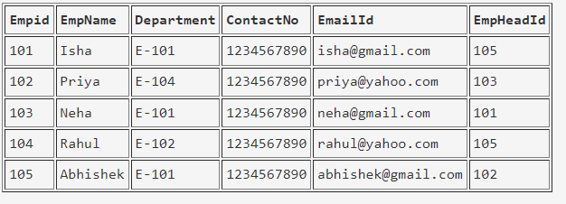

create table employee(empid int primary key,empname varchar(100), department varchar(50),contactno bigint, emaildid varchar(100), empheadid int)

**EmpDept**

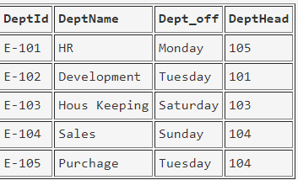

create table empdept(deptid varchar(50) primary key,deptname varchar(100), dept_off varchar(100), depthead int foreign key references employee(empid))

**EmpSalary**

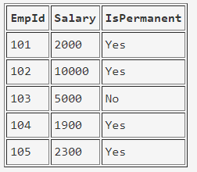

create table empsalary(empid int foreign key references employee(empid), salary bigint, ispermanent varchar(3))

**Project**

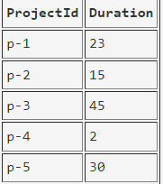

create table project(projectid varchar(50) primary key, duration int)

**Country**

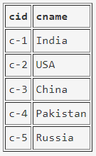

create table country(cid varchar(50) primary key, cname varchar(100))

**ClientTable**

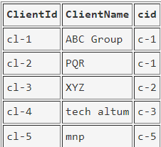

create table clienttable(clientid varchar(50) primary key, clientname varchar(100), cid varchar(50) references country(cid))

**EmpProject**

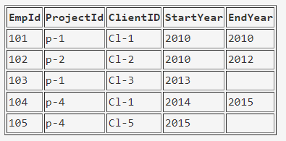

create table empproject(empid int foreign key references employee(empid), projectid varchar(50) foreign key references project(projectid), clientid varchar(50) foreign key references clienttable(clientid),startyear int, endyear int)

**Query:**

1. Select the detail of the employee whose name start with P.
2. How many permanent candidate take salary more than 5000.
3. Select the detail of employee whose emailId is in gmail.
4. Select the details of the employee who work either for department E-104 or E-102.
5. What is the department name for DeptID E-102?
6. What is total salarythat is paid to permanent employees?
7. List name of all employees whose name ends with a.
8. List the number of department of employees in each project.
9. How many project started in year 2010.
10. How many project started and finished in the same year.
11. select the name of the employee whose name's 3rd charactor is 'h'.